**Eline Kroeze at the International Conference on Integrated Care in Lisbon**

APH Aging and Later Life Work Visit Grant 2025

With support from the APH Aging and Later Life Work Visit Grant, I had the opportunity to attend the 25th International Conference on Integrated Care (ICIC25) in Lisbon from May 27–30. ICIC is the leading global event on integrated care, bringing together professionals, researchers, policymakers, and patients to advance the design and delivery of better integrated health and care systems. This year’s overarching theme was: “Synergising Health and Care: Leveraging Integrated Care for a Sustainable Future.”

On Wednesday, I presented early results from our study on short-term residential care (STRC) cost trajectories in the Netherlands. We found substantial variation in costs between clients, with higher costs associated with more hospital use, discharge to nursing homes, and longer STRC stays. Client characteristics explained this variation only partly, suggesting that system-level factors also play a role. Our findings highlight the need to reassess STRC’s role in transitions to long-term care and to strengthen transmural care.

In addition to presenting, I attended many insightful sessions and was inspired by international efforts to make integrated care a practical reality. Outside the conference, I truly enjoyed spending time with colleagues from Amsterdam UMC and Maastricht University.

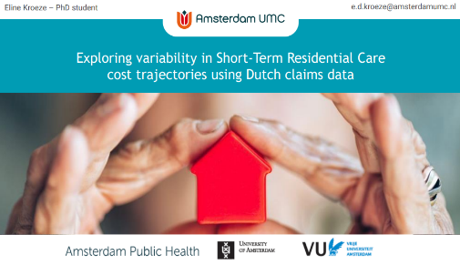

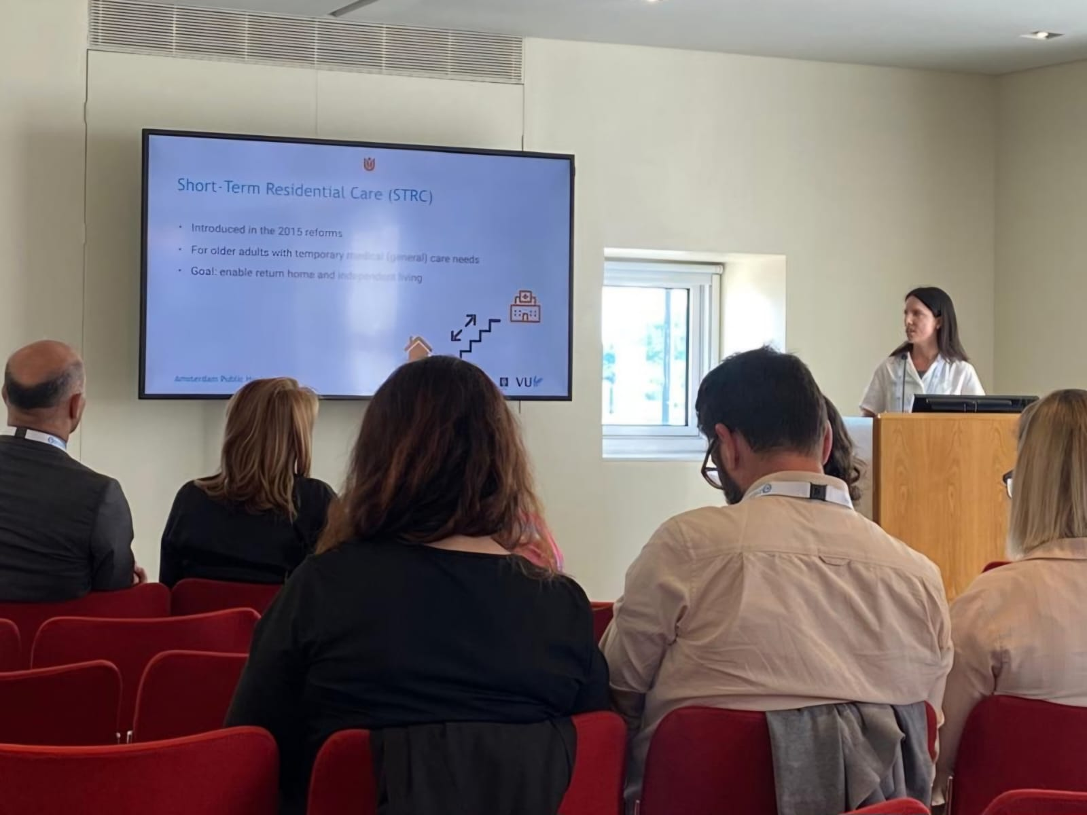

I am very grateful to APH for this wonderful opportunity!

**Eline Kroeze**

PhD Student

Research line Acute Care for Older People

Department of geriatrics & Department of medicine for older people

Amsterdam UMC